**8051 Timers and Counters**

* Timers and counters are one of the best features that is provided by [microcontrollers](https://www.geeksforgeeks.org/microcontroller-and-its-types/).
* Timers are used to measure the time and for creating time delays.
* Counters are used to count the events or tasks that are taking place outside the microcontrollers.
* We can setup these timers and counters with the microcontrollers to make our tasks in different ways to fit in different tasks.

**Types of 8051 Timers and Counters**

* The 8051 microcontrollers mainly has two timers they are **Timer 0** and **Timer 1**. These are used as both **timers** as well as **counters**.
* They are 16-bit long but the format of the microcontroller is 8-bit, due to that the Timers or [counters](https://www.geeksforgeeks.org/counters-in-digital-logic/) are divided into two 8-bit parts a **low byte**and a **high byte**.

**What is Timer 0 (T0):** Timer 0 (T0) in the 8051 microcontroller is a key timer/counter used for timing and event counting. It consists of two 8-bit registers:

**TL0 (Timer 0 Low Byte)**

* TL0 is the lower 8-bit register of Timer 0.
* It stores the lower byte of the count value.
* When timer 0 functions as a 16-bit timer, TL0 increases first, and TH0 increases by one following an overflow (when 255 is achieved).

**TH0 (Timer 0 High Byte)**

* TH0 is the upper 8-bit register of Timer 0.
* It stores the higher byte of the count value.
* When TL0 overflows, Timer 0 can count up to 65,535 (FFFFH) before spilling since TH0 is increased.

**Structure of Timer 0**

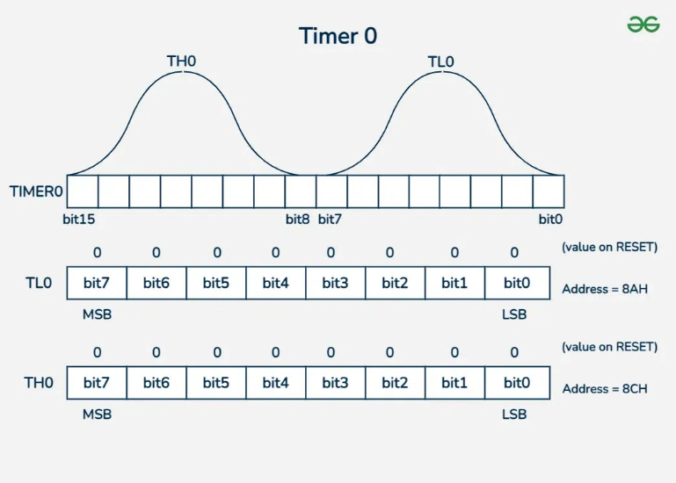

**What is Timer 1 (T1)?**

Timer 1 (T1) in the 8051 microcontroller is another important timer/counter used for timing and event counting. It consists of two 8-bit registers:

**TL1 (Timer 1 Low Byte)**

* Timer 1's bottom 8-bit register is designated as TL1.
* It contains the count value's bottom byte.
* When using a 16-bit timer, TL1 increases first and then TH1 by 1 once TL1 reaches its maximum value of 255.

**TH1 (Timer 1 High Byte)**

* Timer 1's upper 8-bit register is designated as TH1.
* It contains the count value's higher byte.
* When TL1 overflows, TH1 increments, allowing Timer 1 to count up to 65,535 (FFFFH) before overflowing

**Structure of Timer 1**

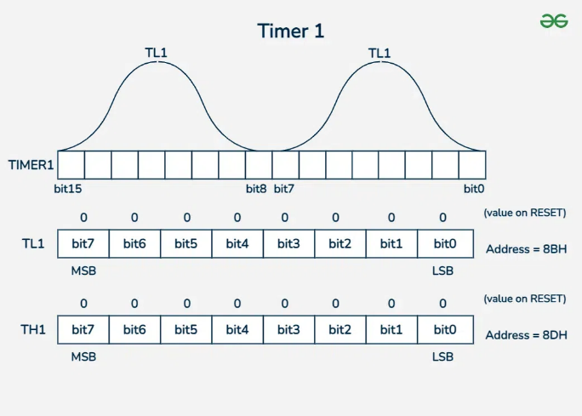

**Timer Control Registers-TCON and TMOD**

**TCON** and **TMOD** are the special function registers in the 8051 microcontroller. These are used to control the timers and counters.

1. **TCON (Timer Control Register)**: The 8051 microcontroller has a unique function register called the **TCON (Timer Control Register)**. In order to provide precise output, timers and counters are controlled by it. The data in the registers may overflow if these timers and counters are not under control. Thus, the TCON is utilized to control the timers and counters.

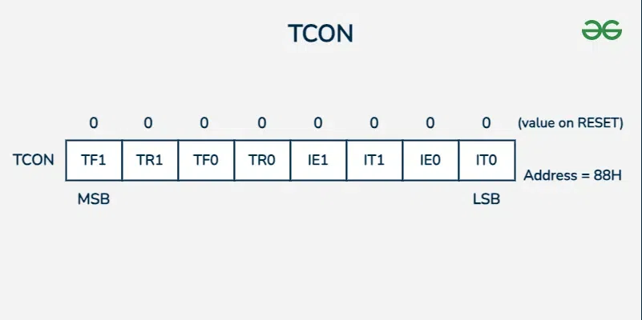

1. **TMOD (Timer Mode Register):** The TMOD (Timer Mode Register) is a special function register in the 8051 microcontrollers. Timer 0 and Timer 1 are the modes of operation that it is utilized to set. Whether a timer or counter needs to be set, it is done so using this register.

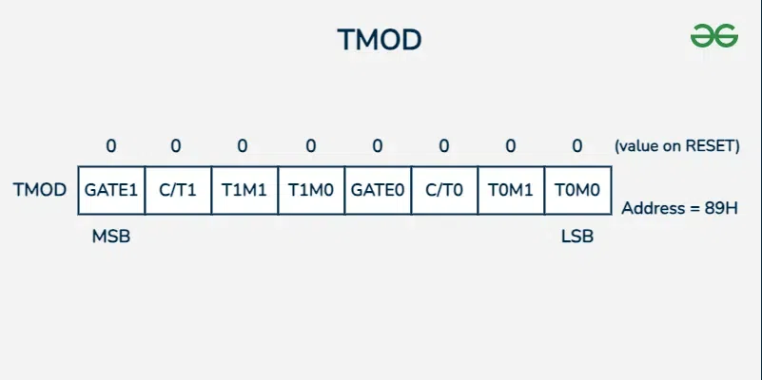

**Timer Counter Modes:**

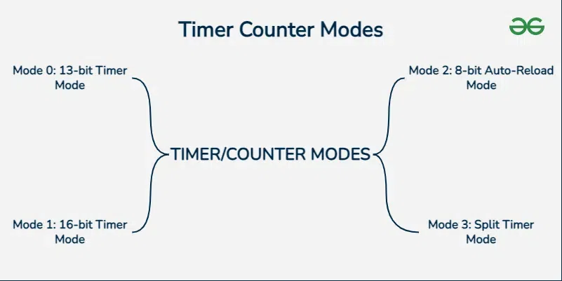

**Timer Modes:**

* Mode 0 (13-bit Timer): A small timer that counts from 0 to 8191. It's rarely used because the range is small. Good for very short delays.

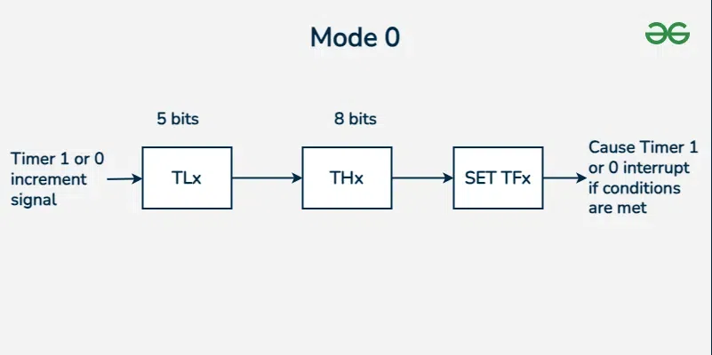

* Mode 1 (16-bit Timer): A bigger timer that counts from 0 to 65535. It's commonly used for most timing tasks like timing events or generating signals (e.g., PWM).

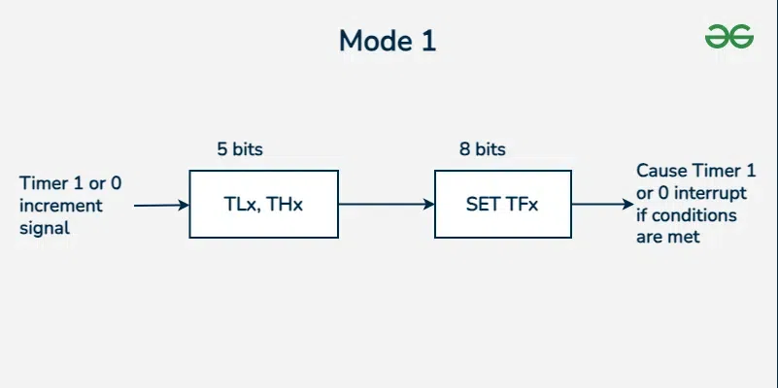

**Counter Modes:**

* Mode 2 (8-bit Auto-Reload): A timer that counts from 0 to 255 and then reloads automatically to continue counting. It's useful for continuous tasks like measuring frequency or generating certain signals.

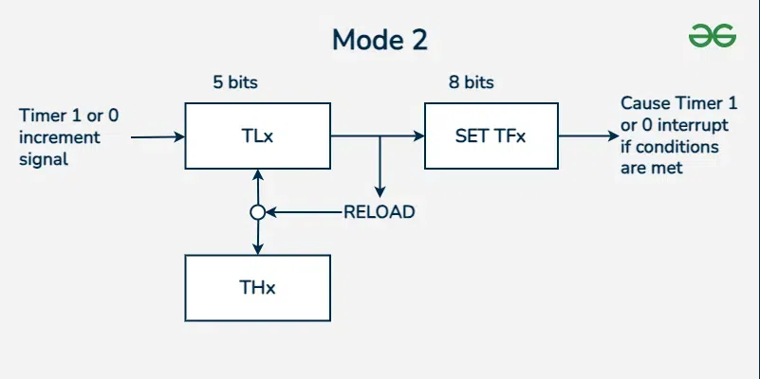

* Mode 3 (Split Timer): Timer 0 is split into two separate 8-bit timers, so you can use them independently while Timer 1 stays as a 16-bit timer. It's helpful when you need two timers for different tasks**.**

